No articles:

* Noun + number
* **Sports**
* **Places, locations, streets**
* **Languages**
* **Companies**
* **Geography**
* **Holidays**
* **Things in general**

Use **plural count nouns**

I love reading ***books***.

Use **non-count nouns**:

I love listening to ***music***.

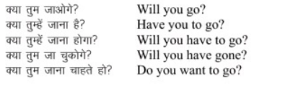

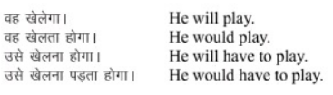

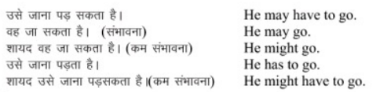

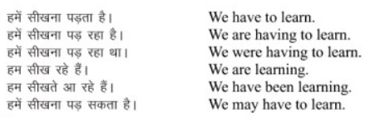

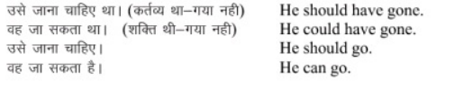

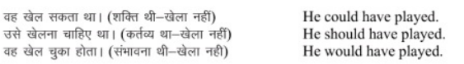

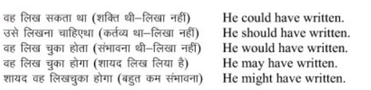

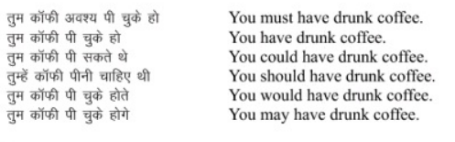



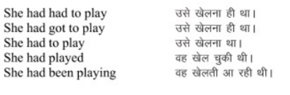

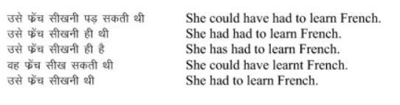

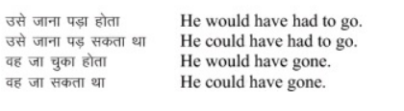

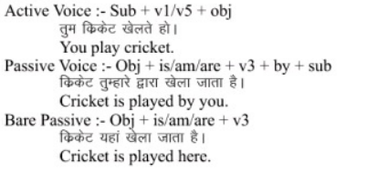

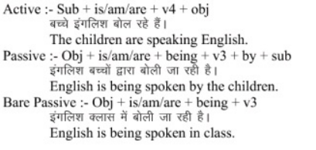

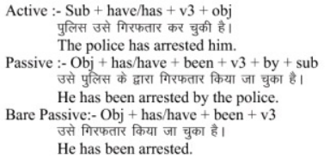

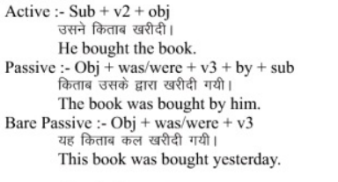

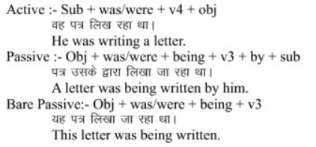

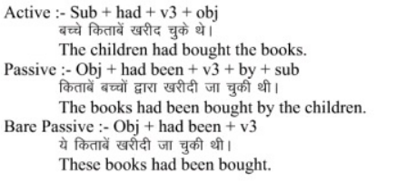

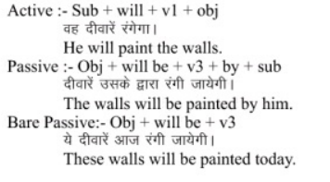

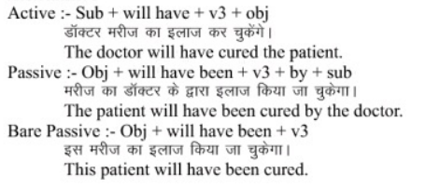

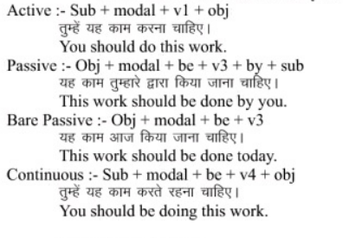

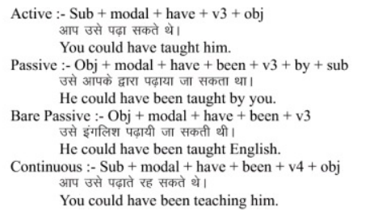

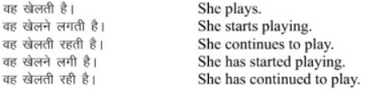

• The children who live in poverty should be helped.

Information about ‘ the children’ defind in relative clause.

The right to freedom of speech is of fundamental importance.

The right is defind in extra information.

Noun of noun:

• The loss of a pet can be a traumatic experience.

We can use the when we make general statements using singular countable nouns

The computer has fundamentally changed the way we interact with our fellow-humans

We can use the when there is only one possible noun:

It has been estimated that the sun is approximately nine billion years old.

The human race faces enormous challenges. (There is only one human race)

• The most popular

use the with superlatives

We usually use the with superlatives

• One of the biggest

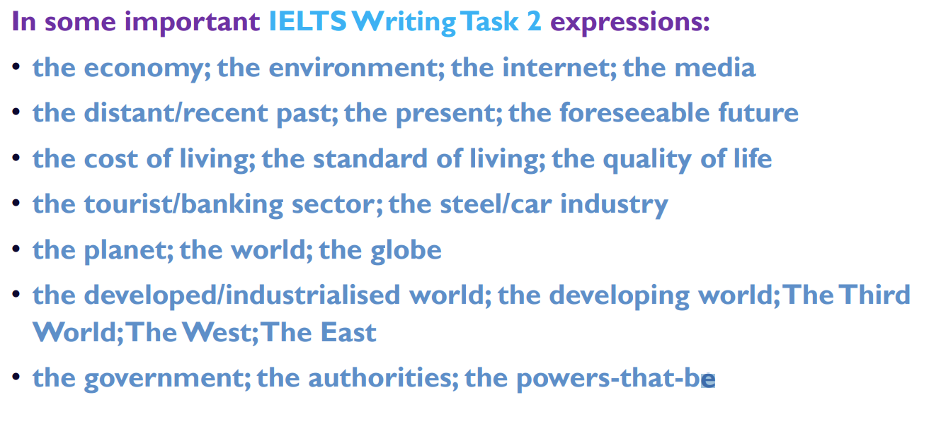

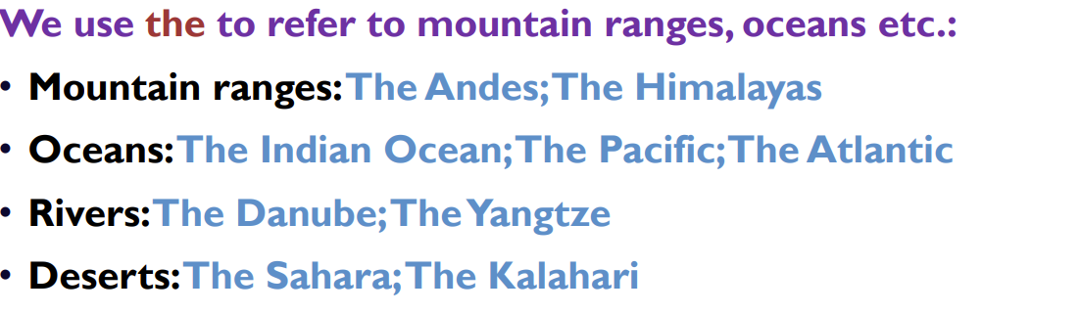

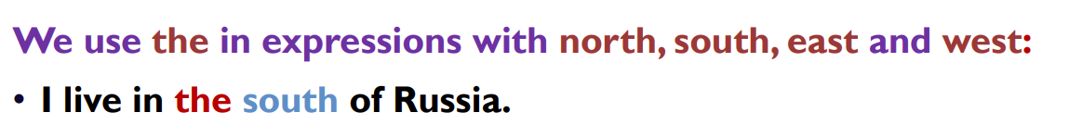

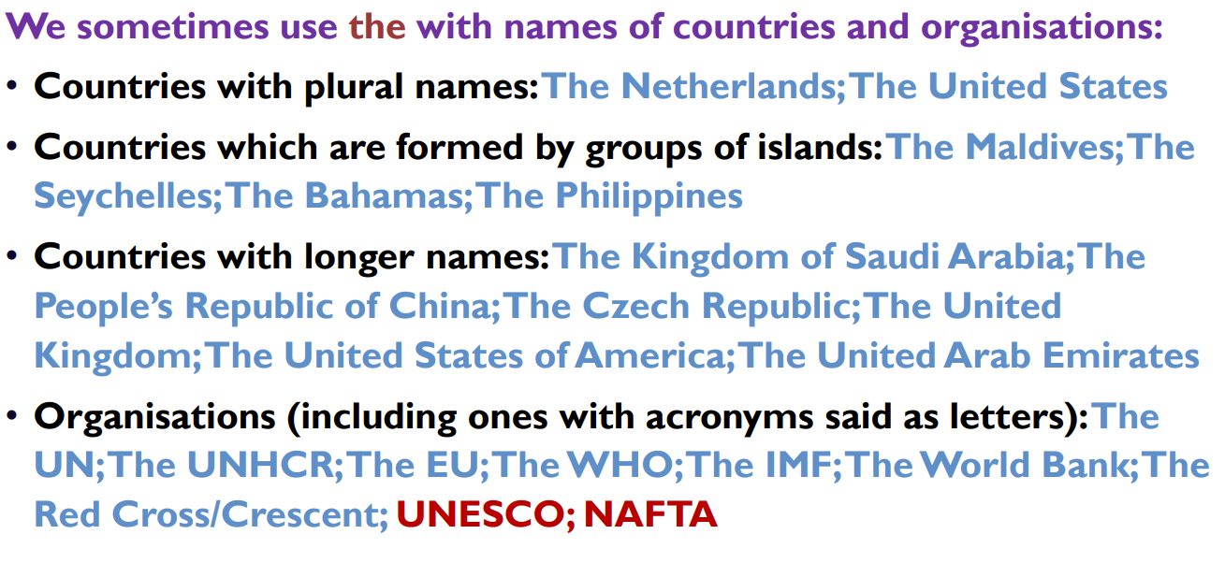

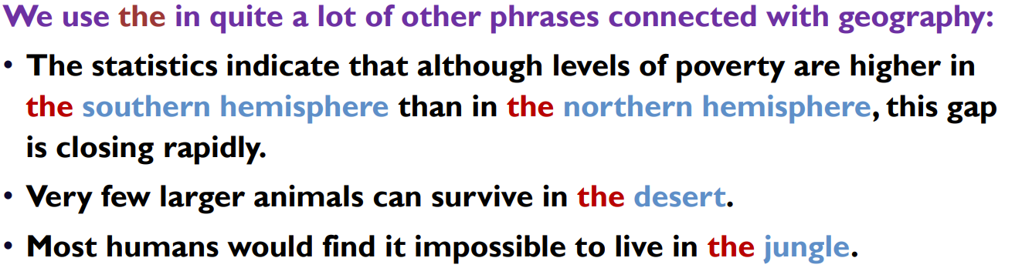

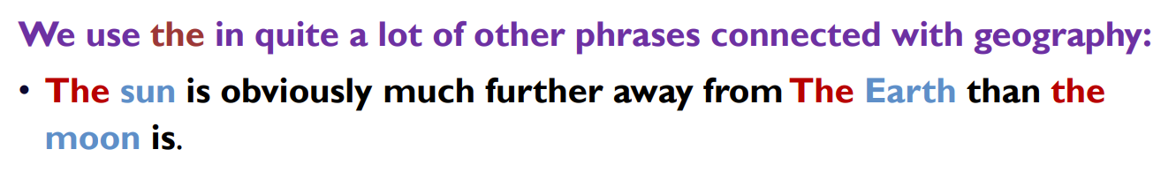

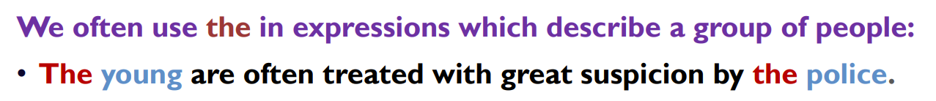

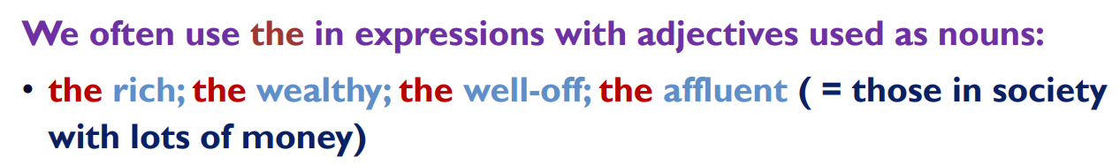

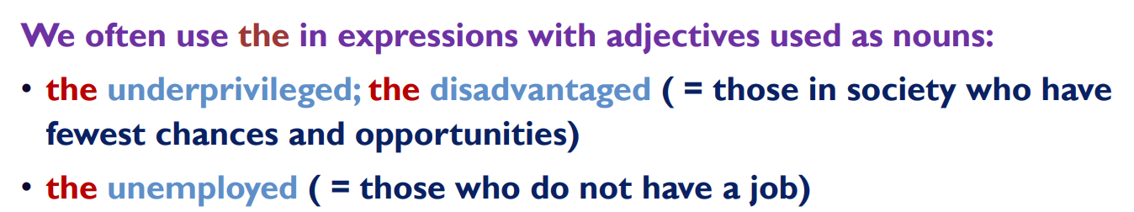

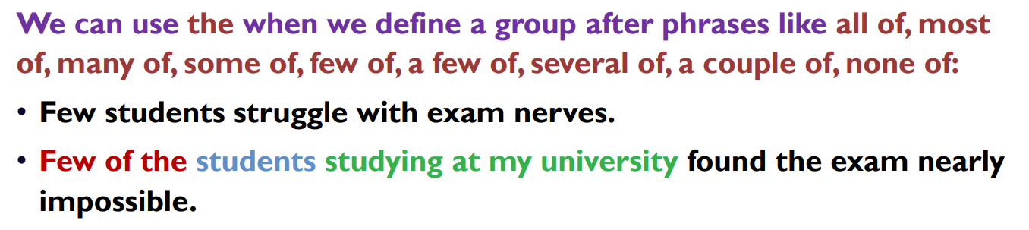

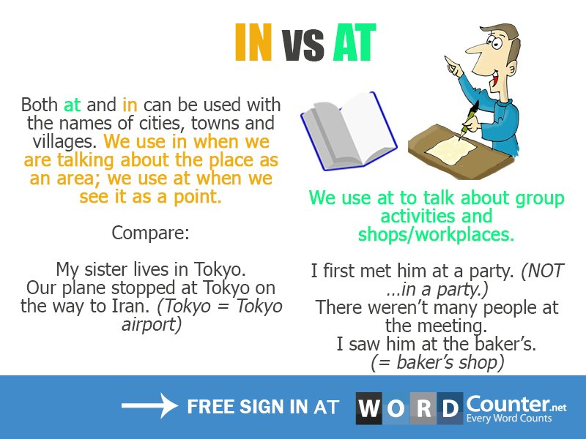

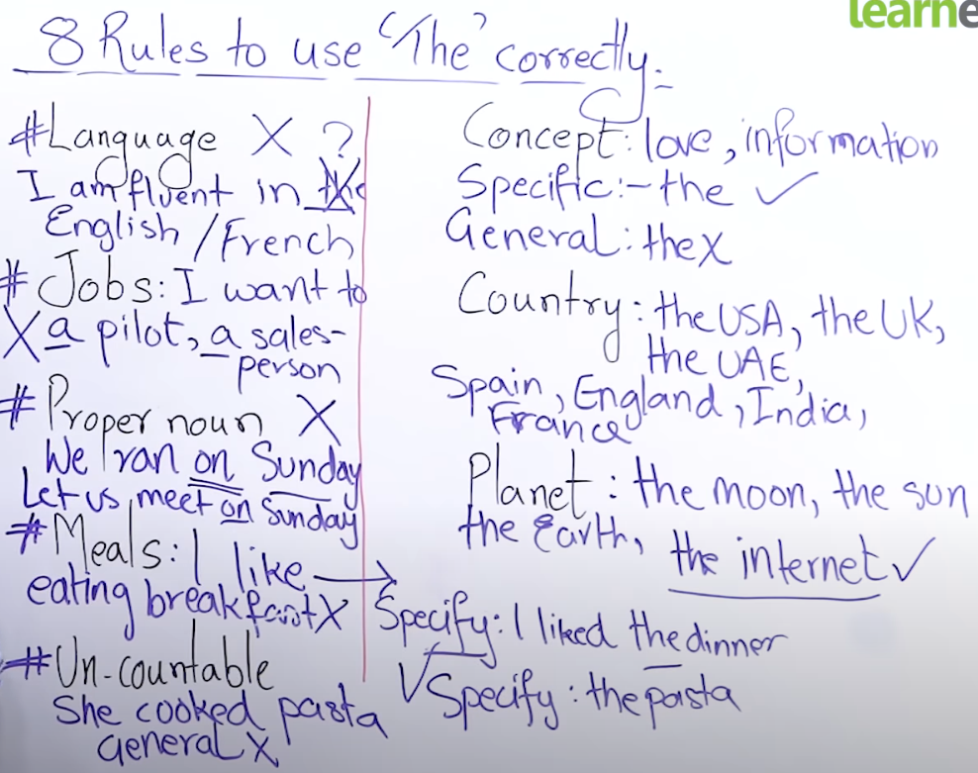

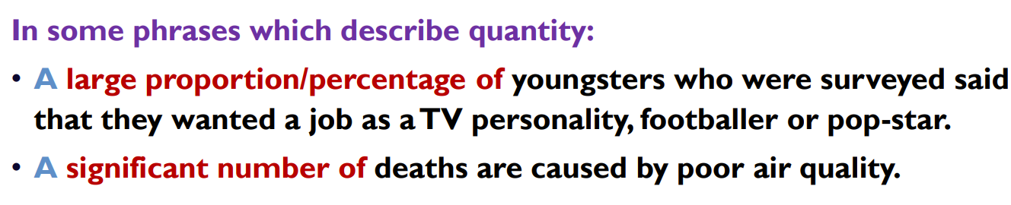

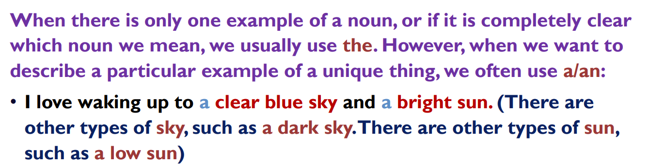

Unique things always use ‘the’

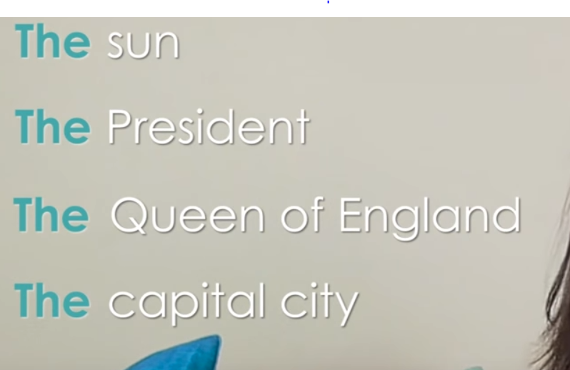

Not common things

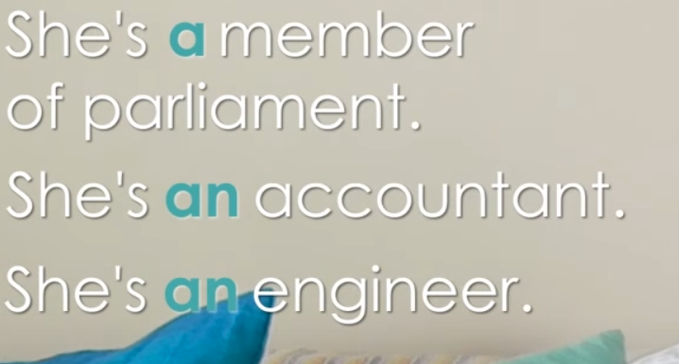

Why the in front of driver because car is one

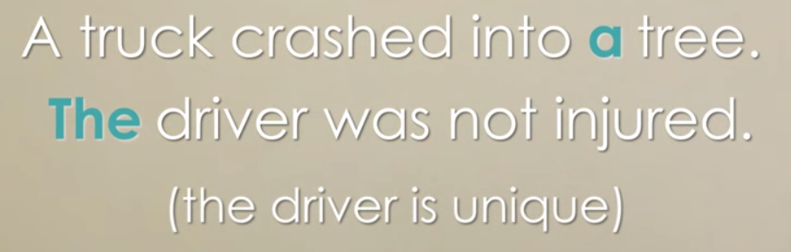

With superlative because there is only one thing that is fastest in the world



In place of unique things and When we use specific postion:

